**CASE STUDY USING REAL LIFE DATABASES APPLICATIONS**

# HOSPITAL MANAGEMENT

## TABLE DESCRIPTION:

SQL> desc hospital;

Name Null? Type

PNAME VARCHAR2(20)

CASE VARCHAR2(20)

WARD VARCHAR2(20)

ROOM_NO NUMBER(3)

FEES NUMBER(9)

## SELECT TABLE:

SQL> select * from hospital;

PNAME CASE WARD ROOM_NO

-

FEES

anu fever general 60

50000

sakthi typhoid icu 80

60000

prithvi cold general 42

30000

PNAME CASE WARD ROOM_NO

-

FEES

jenni malaria general 24

40000

shahi dengu icu 66

70000

## CODING:

**ADD:**

Private Sub Command1_Click()

Adodc1.Recordset.AddNew End Sub

## REPORT:

Private Sub Command2_Click() DataReport1.Show

End Sub

## DELETE:

Private Sub Command3_Click() Adodc1.Recordset.Delete MsgBox "record deleted"

End Sub

## SAVE:

Private Sub Command4_Click() Adodc1.Recordset.Save

End Sub

## FORM DESIGN:

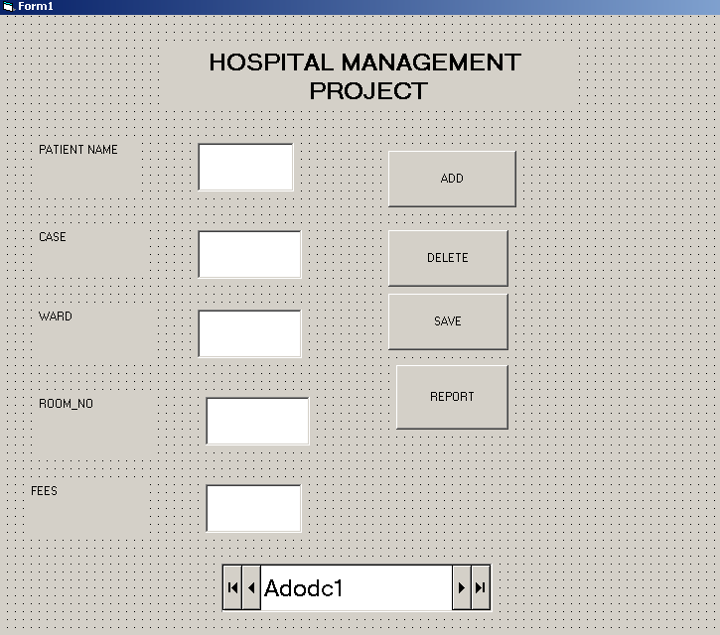

**DATA ENVIRONMENT DESIGN:**

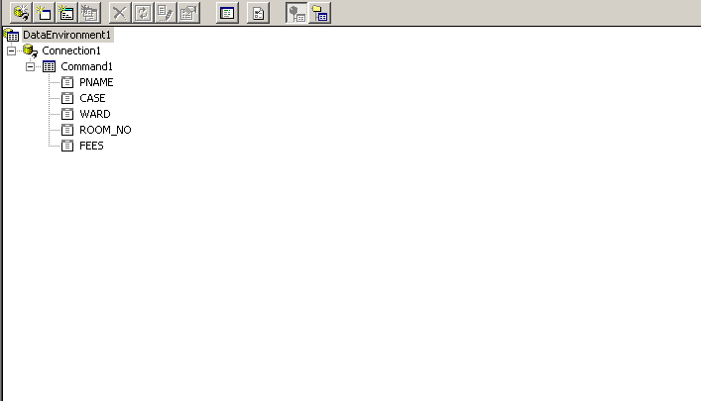

## DATA REPORT DESIGN:

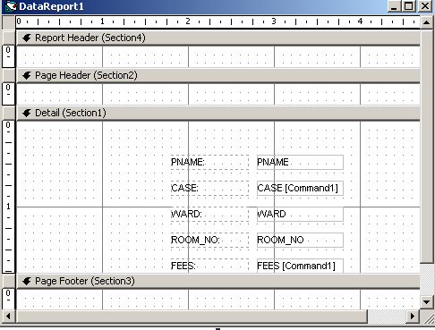

**OUTPUT:**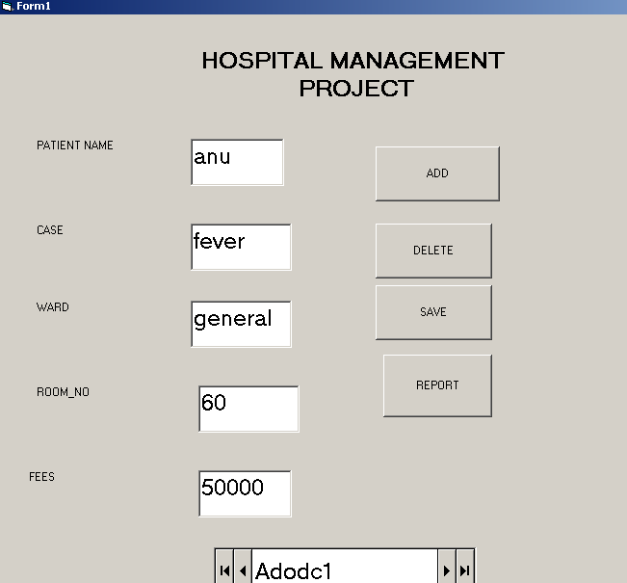

## Report:

